**Name: Sriharivishnu Janakiraman**

**Assesement No:3**

**Date: 10/11/2022**

1)Implement CRUD using Servlets , JSP ,MYSQL, as per below inputs using MVC pattern.

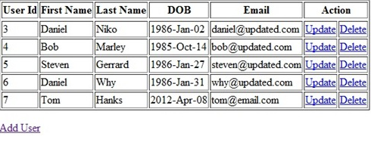

Note: when we click add user ,we need to add the new row after Userid 7 and   
when we say update , that particular should be enabled to change values and updated values to be stored in DB.

Output:

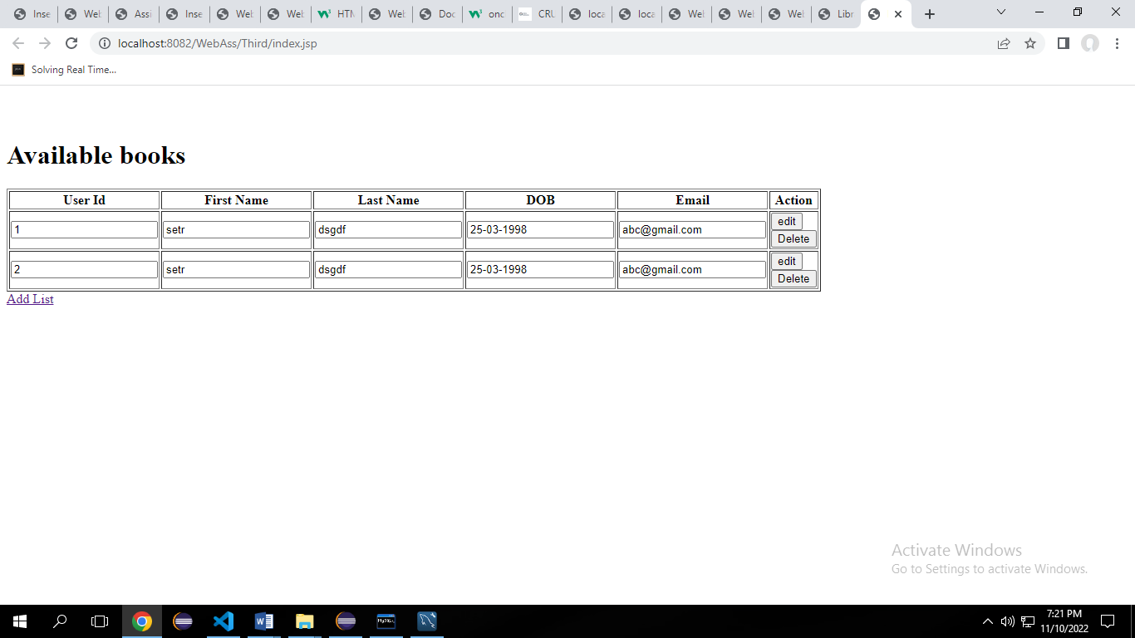

Add Rows

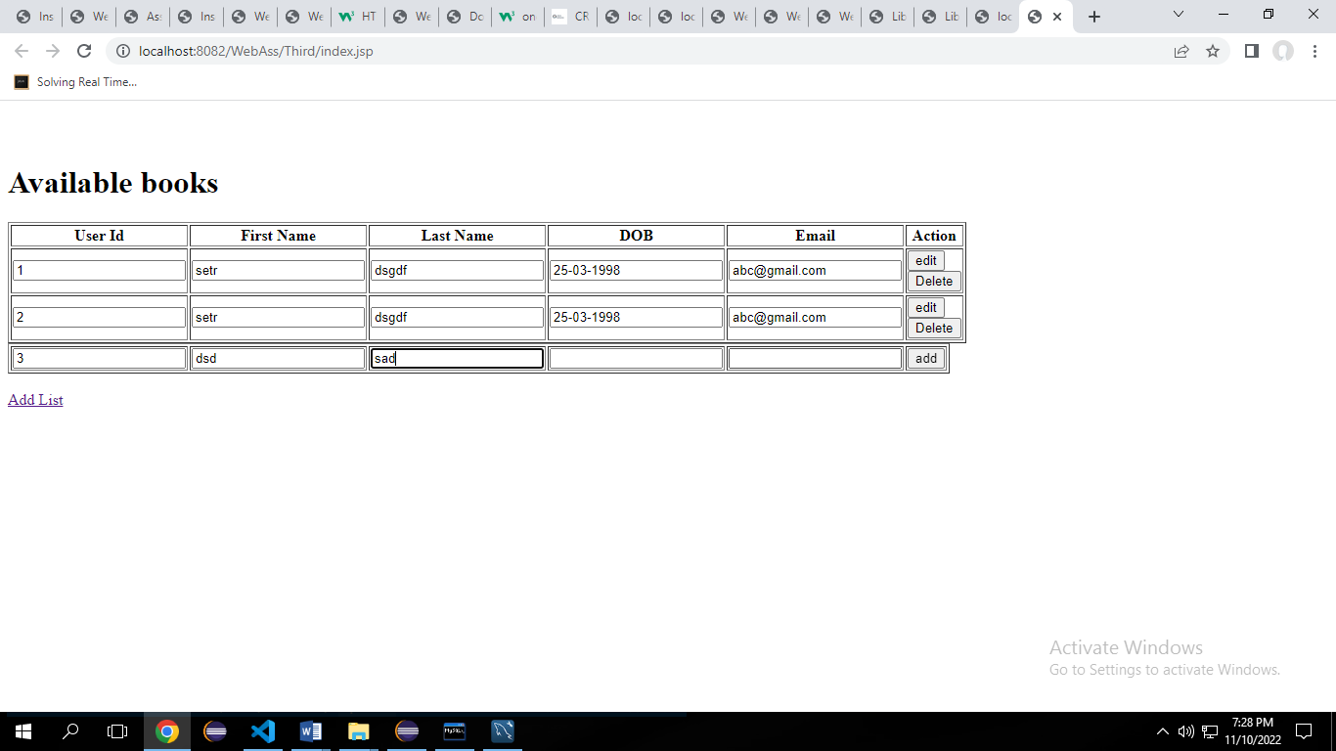

Delete Row:

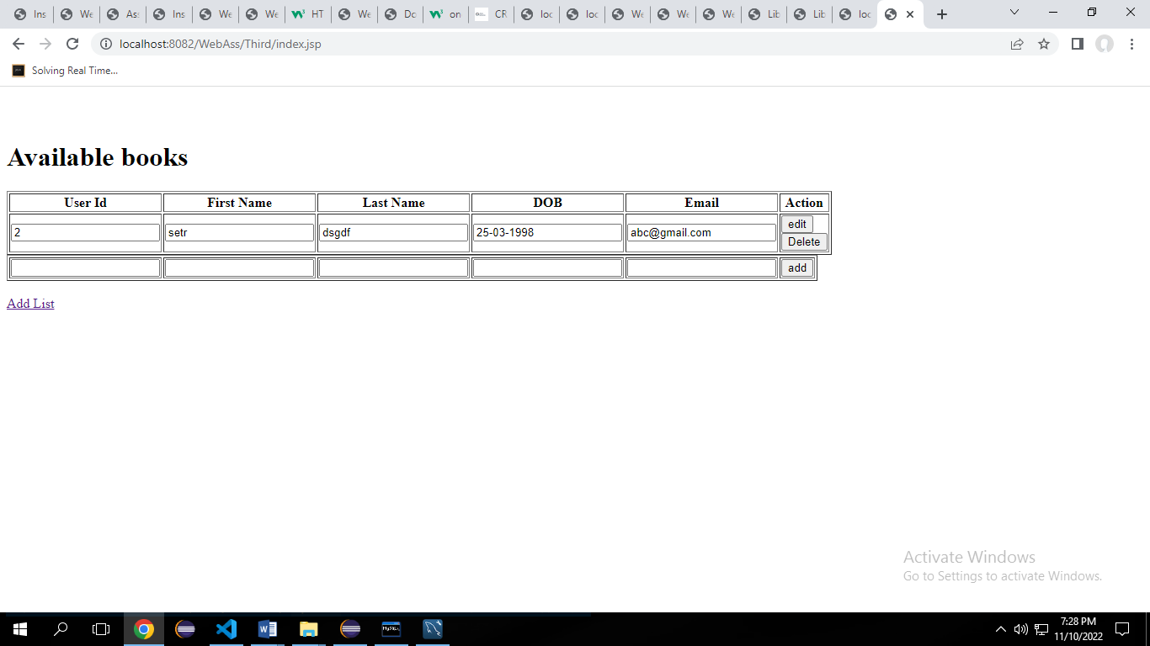

1. Implement CRUD using Hibernate, JSP, JSTL, JDBC, MYSQL for the below web application.

Table info:

JSP:

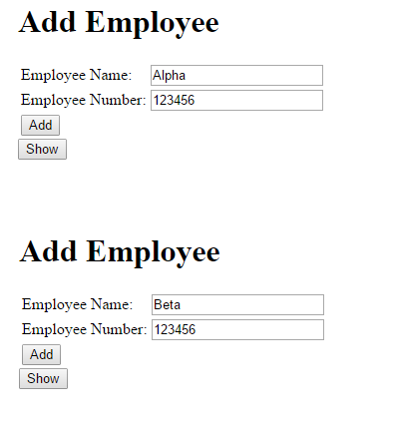

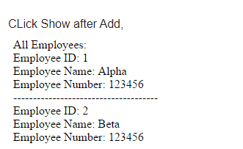

After update:

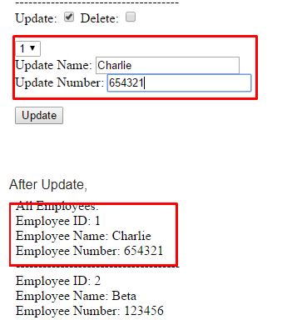

After delete:

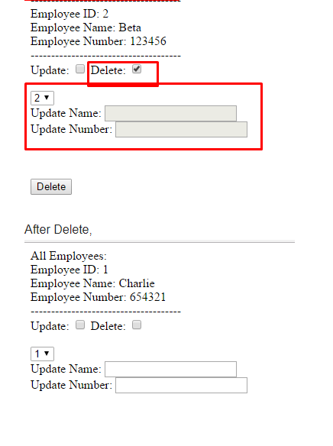

Output:

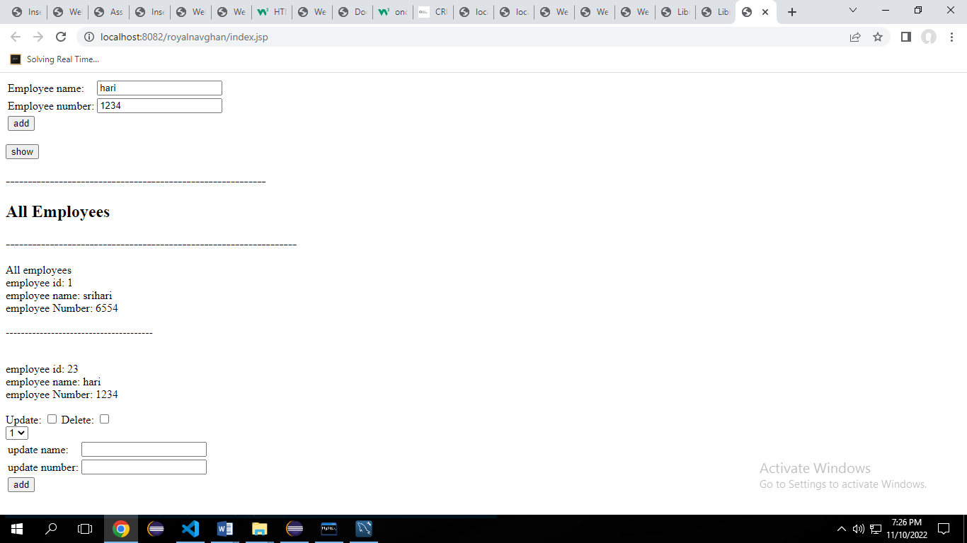

1. Create a web form as given below using JSP and apply below validations with alerts.
2. Fields shall not be empty
3. Name should be minimum 5 characters
4. Password should have one special character and minimum of length 8 chars.

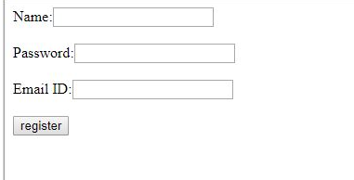

Output:

